Fingerless Gym Gloves, Weight lifting Gloves, Anti-Slip, Breathable, Exercise, for Men and Women Fitness, Cycling, Bodybuilding, Workout, Gym Gloves, MultiColor and Size Option
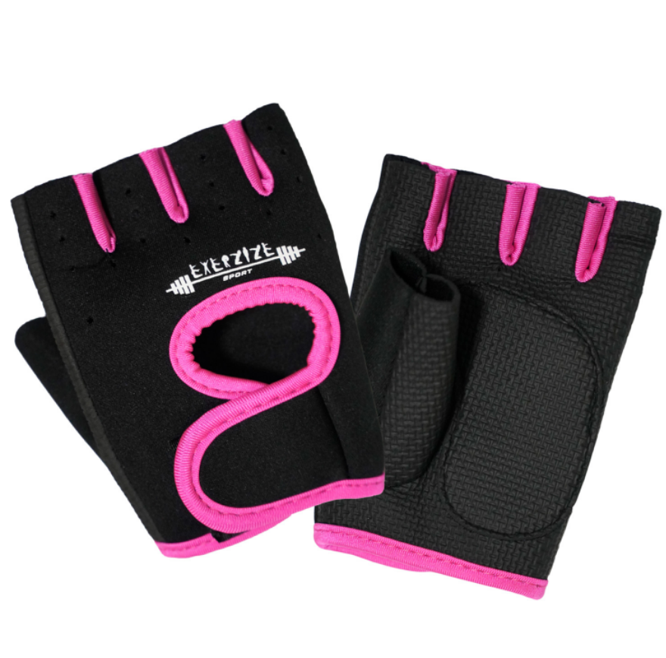

About this item
- ANTI-SLIP WITH NEOPRENE TECHNOLOGY | Get more grip, the whole palm adopts honeycomb silicone anti-skid design. During exercise, you can better hold the barbell and pull up the barbell and kettle bell without slipping off. Gym gloves for men & women fitness enthusiasts and athletes.
- BREATHABLE & COMFORTABLE | The lifting gloves are more breathable. Ventilation and perforation design on the back of the hand. So the gloves will keep your hands dry and comfortable.
- ADJUSTABLE WRIST STRAP SUPPORT | The straps of the weight lifting gloves have been lengthened, effectively reducing the damage to the wrist and the strain of the ligament. Excellent wrist support for Olympic lifts like snatches, clean and jerks, front squats, and other lifts requiring wrist protection
- MULTIPURPOSE USAGE | Whenever you need, Weight Lifting, Pull Up, Bodybuilding, Gym Training, Powerlifting, Cross fit Training, Cycling, Driving and more outdoor exercise.
- FULL PROTECTION | No more hand injuries and calluses, the thickened palm rest covers the entire palm and fingers. The workout gloves are made of high-quality Silicon Printed Neoprene, wear-resistant & super durable. Suitable for weight training, fitness, bodybuilding, rock climbing, etc

Technical Details
Color | ‎Black Pink
Size | ‎S
Material type | ‎Neoprene
Sport | ‎Exercise and Fitness
Brand | ‎LMS Data
Department | ‎Women's
Manufacturer | ‎LMS Data
Package Dimensions | ‎15 x 9 x 3 cm; 50 Grams
ASIN | ‎B09BB7K6CS

Additional Information
Date First Available | 27 July 2021
Best Sellers Rank | 2,898 in Sports & Outdoors (See Top 100 in Sports & Outdoors)  18 in Weight Lifting Gloves

Part number: EX-GLVS-PNK

